4. AQUACULTURE METHODS AND PRACTICES: A SELECTED REVIEW

4.1 Historical Perspective
4.2 Overview of Aquaculture Methods and Practices
4.3 Fish Pond Culture
4.4 Integrated Fish Farming
4.5 Pen and Cage Culture
4.6 Open Water Culture

4.1 Historical Perspective
Aquaculture has a tradition of about 4 000 years. It began in China, possibly due to the desires of an emperor to have a constant supply of fish. It is speculated that the techniques for keeping fish in ponds originated in China with fishermen who kept their surplus catch alive temporarily in baskets submerged in rivers or small bodies of water created by damming one side of a river bed. Another possibility is that aquaculture developed from ancient practices for trapping fish, with the operations steadily improving from trapping-holding to trapping-holding-growing, and finally into complete husbandry practices (Ling, 1977).
Table 5. Possible environmental Impacts of aquaculture
Culture System | Environmental Impact
EXTENSIVE
1. Seaweed culture | May occupy formerly pristine reefs; rough weather losses; market competition; conflicts/failures, social disruption.
2. Coastal bivalve culture (mussels, oysters, clams, cockles) | Public health risks and consumer resistance (microbial diseases, red tides, industrial pollution; rough weather losses; seed shortages; market competition especially for export produce; failures, social disruption.
3. Coastal fishponds (mullets, milkfish, shrimps, tilapias) | Destruction of ecosystems, especially mangroves; increasingly non-competitive with more intensive systems; nonsustainable with high population growth; conflicts/failures, social disruption.
4. Pen and cage culture in eutrophic waters and/or rich benthos (carps, catfish, milkfish tilapias) | Exclusion of traditional fishermen; navigational hazards; conflicts, social disruption; management difficulties; wood consumption.
SEMI-INTENSIVE
1. Fresh- and brackishwater pond (shrimps and prawns, carps, catfish, milkfish, mullets, tilapias) | Freshwater: health risks to farm workers from waterborne diseases. Brackishwater: salinization/acidification of soils/aquifers. Both: market competition, especially for export produce; feed and fertilizer availability/prices; conflicts/failures, social disruption.
2. Integrated agriculture-aquaculture (rice-fish; live stock/poultry-fish; vegetables - fish and all combinations of these) | As freshwater above, plus possible consumer resistance to excreta-fed produce; competition from other users of inputs such as livestock excreta and cereal brans; toxic substances in livestock feeds (e.g., heavy metals) may accumulate in pond sediments and fish; pesticides may accumulate in fish.
3. Sewage-fish culture (waste treatment ponds; latrine wastes and septage used as pond inputs; fish cages in wastewater channels) | Possible health risks to farm workers, fish processors and consumers; consumer resistance to produce.
4. Cage and pen culture, especially in eutrophic waters or on rich benthos (carps, catfish, milkfish, tilapias) | As extensive cage and pen Systems above.
INTENSIVE
1. Freshwater, brackishwater and marine ponds (shrimps; fish, especially carnivores - catfish, snakeheads, groupers, sea bass, etc.) | Effluents/drainage high in BOD and suspended solids; market competition, especially for export product; conflicts/failures, social disruption.
2. Freshwater, brackishwater and marine cage and pen culture (finfish, especially carnivores -groupers, sea bass, etc. - but also some omnivores such as common carp) | Accumulation of anoxic sediments below cages due to fecal and waste feed build-up; market competition, especially for export produce; conflicts/failures, social disruption; consumption of wood and other materials.
3. Other - raceways, silos, tanks, etc. | Effluents/drainage high in BOD and suspended solids; many location-specific problems.
Source: Modified from Pullin, 1989
Chinese who emigrated to other Southeast Asian countries probably carried the knowledge with them and inspired the local people to take up fish farming. Brackishwater aquaculture is thought to have originated in Indonesia with the culture of milkfish and grey mullet (Ling, 1977) and must have spread to neighbouring countries like the Philippines which has been practising it for about 300 to 400 years (Baluyut, 1989).
The husbandry of fish is therefore not a new phenomenon. Ancient practices based on the modifications of natural bodies of water or wetlands to entrap young fish in enclosures until harvest, have just evolved into more systematic and scientific methods and techniques.
Other regions of the world have shorter traditions of aquaculture. In North America, it is about a century old; in Africa, aquaculture production consists almost exclusively of tilapia culture in freshwater ponds and dates back to the 1940s (UNDP/NORAD/FAO, 1987). Aquaculture development has been very recent and is just gaining momentum in Australia, New Zealand, and the Pacific Island countries (Rabanal, 1988b).

4.2 Overview of Aquaculture Methods and Practices
A number of aquaculture practices are used world-wide in three types of environment (freshwater, brackishwater, and marine) for a great variety of culture organisms. Freshwater aquaculture is carried out either in fish ponds, fish pens, fish cages or, on a limited scale, in rice paddies. Brackishwater aquaculture is done mainly in fish ponds located in coastal areas. Marine culture employs either fish cages or substrates for molluscs and seaweeds such as stakes, ropes, and rafts. (Summarized information on major culture systems and practices used for the principal culture organisms on a regional basis, is given in Table 6.)
Culture systems range from extensive to intensive depending on the stocking density of the culture organisms, the level of inputs, and the degree of management. In countries where government priority is directed toward increased fish production from aquaculture to help meet domestic demand, either as a result of the lack of access to large waterbodies (e.g., Nepal, Central African Republic) or the over-exploitation of marine or inland fisheries (e.g., Thailand, Zambia), aquaculture practices are almost exclusively oriented toward production for domestic consumption (UNDP/NORAD/FAO, 1987).
These practices include:
(i) freshwater pond culture;
(ii) rice-fish culture or integrated fish farming;
(iii) brackishwater finfish culture;
(iv) mariculture involving extensive culture and producing fish/shellfish (e.g., oysters, mussels, cockles) which are sold in rural and urban markets at relatively low prices.
Table 6. Aquaculture production systems and practices, by region
Region | Major Culture Species | Major Culture Systems | Major Culture Practices | Scope for Future Development/Needs for Further Expansion
ASIA | At least 75 species; diverse freshwater and marine species, including high-value shrimps, molluscs, seaweeds, with carps and seaweeds dominating production | Traditional extensive to intensive | - Fish ponds  - Fish pens and fish cages  - Floating rafts, lines, and stakes for molluscs and seaweeds | Development of culture-based fisheries in inland lakes, rivers, floodplains, and permanent and temporary reservoirs and barrages
 |  |  |  | Resource enhancement programmes integrated with environmental management
PACIFIC | Mussels and oysters, red seaweeds | Intensive/semi-intensive to extensive | - Hanging lines for mussels and pearl oysters | Production of high-value species for select markets;
 |  |  | - Offshore cages for salmon | Small-scale aquaculture for local markets;
 |  |  | - Pond culture for shrimps, tilapia, catfish, milkfish | Improved management of fishery resources, particularly reef fisheries
 |  |  | - Freshwater pens for crayfish
LATIN AMERICA | 50 species of fish, crustaceans, and molluscs, including freshwater fish and marine shrimps in South America and molluscs in Central America | Extensive to semi-intensive and Intensive | - Offshore cage farming of Pacific and Atlantic salmon  - Ocean ranching in Southern Ocean  - Semi-intensive farming of marine shrimp in coastal ponds and extensive farming of freshwater fish in ponds | Production of species for export and marine shrimp and salmon
AFRICA | >26 freshwater fish; the most important being tilapia and common carp, molluscs and oysters also | Mainly extensive, rural-based, integrated with poultry and animal husbandry, rice-fish farming; some intensive in raceways and floating cages | - Fish pond culture for freshwater fish  - Raceways and floating cages for marine species | Increased emphasis on higher value catfishes for urban markets, on marine species of fish and crustaceans for select national market and export
 |  |  |  | Culture-based fisheries in lakes and reservoirs
 |  |  |  | Development of coastal lagoons which are almost totally unexploited
MEDITERRANEAN | >50 individual species, mostly freshwater and brackishwater fishes - most important being salmonids and carps; oysters and mussels | Well-diversified modern practices, with highly technical and intensive systems in developing countries and semi-intensive and extensive elsewhere | - Fish pond  - Fish cages  - Ocean ranching | Production of high-value species of tourism and export  Integrated coastal zone management
CARIBBEAN | About 16 species of tilapias, carps, marine shrimp and, freshwater prawns, oysters and seaweeds |  | - Floating cages in reservoirs | Priority is for aquaculture production for local markets
 |  |  | - Fish pond farming in freshwater
 |  |  | - Culture-based fisheries in reservoirs
 |  |  | - Rope production of molluscs
Source: ADCP Aquaculture Regional Profiles, 1989b
Extensive systems use low stocking densities (e.g., 5 000-10 000 shrimp post larvae (PL)/ha/crop) and no supplemental feeding, although fertilization may be done to stimulate the growth and production of natural food in the water. Water change is effected through tidal means, i.e., new water is let in only during high tide and the pond can be drained only at low tide. The ponds used for extensive culture are usually large (more than two ha) and may be shallow and not fully cleared of tree stumps. Production is generally low at less than 1 t/ha/y.
Semi-intensive systems use densities higher than extensive systems (e.g., 50 000-100 000 shrimp PL/ha/crop) and use supplementary feeding. Intensive culture uses very high densities of culture organism (e.g., 200 000-300 000 shrimp PL/ha/crop) and is totally dependent on artificial, formulated feeds. Both systems use small pond compartments of up to one ha in size for ease of management.
Semi-intensive and intensive culture systems are managed by the application of inputs (mainly feeds, fertilizers, lime, and pesticides) and the manipulation of the environment primarily by way of water management through the use of pumps and aerators. Feeding of the stock is done at regular intervals during the day. In intensive shrimp culture, the computed daily feed ration is given in equal doses from as low as three to as high as six times a day. Water change is also effected on a daily basis, with approximately 10-15% of the water in the pond replenished by the entry of new water in semi-intensive shrimp ponds.
Semi-intensive and intensive culture systems are therefore more labour-intensive than extensive systems which need little attention, and are costlier to set up and operate, not to mention the fact that they also carry higher risks of mortalities resulting from disease, poor management, and/or force majeure (e.g., from anoxia due to non-functioning aerators during times of power failure).
Production is of course much higher (for example, ranging from a minimum of 1.5 t/ha/crop from semi-intensive shrimp culture to a high of 10 t/ha/crop from intensive shrimp culture). Financial returns are therefore much more attractive than those from extensive culture, although studies have shown that the return on investment (ROI) from semi-intensive culture is better than from intensive culture due to the high cost of inputs (largely fry and feeds) used in intensive culture.
A summary of the comparative features among these three main types of culture systems is shown in Table 7.

4.3 Fish Pond Culture

4.3.1 Culture Species
4.3.2 Site Selection
4.3.3 Pond Layout
4.3.4 Design of Pond Facilities
4.3.5 Pond Management

Pond culture, or the breeding and rearing of fish in natural or artificial basins, is the earliest form of aquaculture with its origins dating back to the era of the Yin Dynasty (1400-1137 B.C.). Over the years, the practice has spread to almost all parts of the world and is used for a wide variety of culture organisms in freshwater, brackishwater, and marine environments. It is carried out mostly using stagnant waters but can also be used in running waters especially in highland sites with flowing water.
Table 7. Summary of comparative features among the three main culture systems
Parameter | Extensive | Semi-Intensive | Intensive
Species Used | Monoculture or Polyculture | Monoculture | Monoculture
Stocking Rate | Moderate | Higher than extensive culture | Maximum
Engineering Design and Layout | May or may not be well laid-out | With provisions for effective water management | Very well engineered system with pumps and aerators to control water quality and quantity
 | Very big ponds | Manageable-sized units (up to 2 ha each) | Small ponds, usually 0.5-1 ha each
 | Ponds may or may not be fully cleaned | Fully cleaned ponds | Fully cleaned ponds
Fertilizer | Used to enhance natural productivity | Used regularly with lime | Not used
Pesticides | Not used | Used regularly for prohylaxis | Used regularly for prophylaxis
Food and Feeding Regimen | None | Regular feeding of high quality feeds | Full feeding of high-quality feeds
 |  | Depending on stocking density used, formulated feeds may be used partially or totally
Cropping Frequency (crops/y) | 2 | 2.5 | 2.5
Quality of Product | Good quality | Good quality | Good quality
 | Culture species dominant but extraneous species may occur | Confined to culture species | Confined to culture species
 | Variable sizes | Uniform sizes | Uniform sizes
Running water fish culture involves growing the fingerlings to marketable size in earthen ponds using water from rivers, irrigation canals, or plain rain water. The system approximates intensive culture in that it involves the application of rapid water changes and the heavy stocking of the cultured species. The continuously flowing water is advantageous for fish culture as it supplies abundant dissolved oxygen and flushes away waste products and unconsumed feeds.

4.3.1 Culture Species
Commonly raised species in freshwater ponds are the carps, tilapia, catfish, snakehead, eel, trout, goldfish, gouramy, trout, pike, tench, salmonids, palaemonids, and the giant freshwater prawn Macrobrachium. In brackishwater ponds, common species include milkfish (Chanos chanos), mullet (Mugil sp.) and the different penaeid shrimps (Penaeus monodon, P. orientalis, P. merguiensis, P.penicillatus, P. semisulcatus, P. japonicus, and M. ensis). The more popular species for culture in marine ponds are the sea bass, grouper, red sea bream, yellowtail, rabbitfish, and marine shrimps.
In Asia, where the bulk of world production from aquaculture emanates, fish ponds are mostly freshwater or brackishwater, and rarely marine. In China and most of the Indian sub-continent, pond culture is traditionally dominated by freshwater species, mainly the carps, usually in polyculture and/or integrated with animal husbandry. In Southeast Asia, fish ponds are predominantly brackishwater, with milkfish and penaeid shrimps grown either in polyculture or in monoculture.
Recently in Latin America and the Caribbean, brackishwater pond culture of penaeid shrimps has expanded rapidly, as it has in some parts of Asia.
In Africa, the tilapias and carps dominate aquaculture production. Controlled breeding is also carried out in ponds with goldfish, trout, Bagrus and, to a lesser extent, Lates niloticus, Heterotis niloticus, and Clarias lazera. Ten species of molluscs belonging to four genera (Crassostrea, Mytilus, Venerupis and Pinctada) are cultured. Crustacean culture has yet to be developed on a significant scale (Satia, 1989).

4.3.2 Site Selection
Proper site selection is recognized as the first step guaranteeing the eventual success of any aquaculture project and forms the basis for the design, layout, and management of the project (SCSP, 1982a). For fish ponds, especially those to be used for coastal/brackishwater aquaculture of high-value species like shrimps, site selection is critical and should be given utmost attention.
Adisukresno (1982), Hechanova (1982), and Jamandre and Rabanal (1975) listed the following guidelines for the selection of a suitable site for coastal fish ponds:
(i) Soil Quality: preferably, clay-loam, or sandy-clay for water retention and suitability for diking; alkaline pH (7 and above) to prevent problems that result from acid-sulphate soils (e.g., poor fertilizer response; low natural food production and slow growth of culture species; probable fish kills).
(ii) Land elevation and tidal characteristics; preferably with average elevation that can be watered by ordinary high tides and drained by ordinary low tides; tidal fluctuation preferably moderate at 2-3 m. (Sites where tidal fluctuation is large, say 4 m, are not suitable because they would require very large, expensive dikes to prevent flooding during high tide. On the other hand, areas with slight tidal fluctuation, say 1 m or less, could not be drained or filled properly.)
(iii) Vegetation; preferably without big tree stumps and thick vegetation which entail large expense for clearing; areas near river banks and those at coastal shores exposed to wave action require a buffer zone with substantial growths of mangrove. (The presence of Avicennia indicates productive soil; nipa and trees with high tannin content indicate low pH.)
(iv) Water supply and quality: with steady supply of both fresh and brackish water in adequate quantities throughout the year; water supply should be pollution-free and with a pH of 7.8-8.5.
(v) Accessibility: preferably readily accessible by land/water transport; close to sources of inputs such as fry, feeds, fertilizers, and markets, fish ports, processing plants, and ice plants; and linked by communication facilities to major centres.
(vi) Availability of manpower for construction and operation.

4.3.3 Pond Layout
The layout of the pond system depends on the species for culture and on the size and shape of the area, which in turn determines the number and sizes of ponds and the position of the water canals and gates. A fish farm is considered properly planned if all the water control structures, canals, and the different pond compartments mutually complement each other (SCSP, 1982a). A complete fish farm has nursery and grow-out ponds and, in some instances, transition ponds for intermediate-sized fish/shrimp, all of which are properly proportioned and positioned within (Fig. 1).
Milkfish culture in brackishwater ponds in the Philippines follows the traditional practice of providing for nursery, transition, and rearing operations. In some cases, formation ponds are used for additional growth or stunting of fingerlings prior to stocking in rearing ponds (Fig. 2). The nursery ponds comprise about 1-4% of the total production area while the transition and formation ponds constitute about 6-9% of total area (Camacho and Lagua, 1988).
It has been suggested that a similar progressive culture scheme be adopted for shrimp pond culture when no supplementary feeding is practised. For growing to a medium size, a two-stage progression composed of a nursery pond (NP) and a rearing pond (RP) is adequate (Fig. 3); for growing to larger sizes, a three-stage progression composed of nursery, transition, and rearing ponds is recommended (Fig. 4) (ASEAN/SCSP, 1978).
Fig. 1. Layout of conventional pond system (from Camacho and Lagua, 1988).
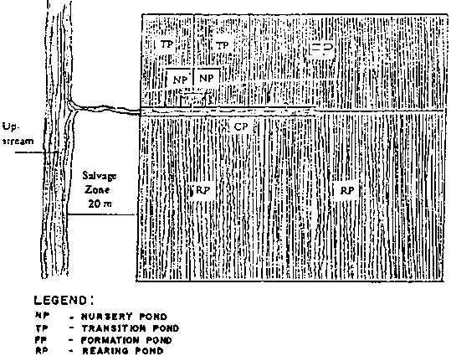
Fig. 2. Modular pond system for milkfish culture (from Camacho and Lagua, 1988).
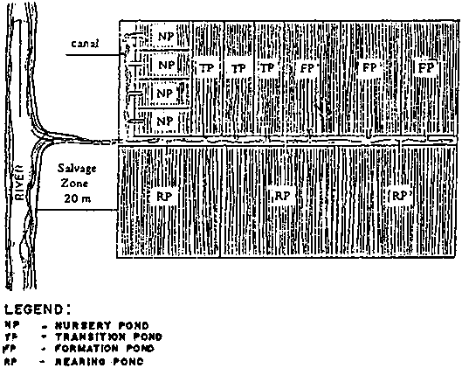
Fig. 3. Pond layout with one nursery pond and three rearing ponds (from ASEAN/SCSP, 1978).
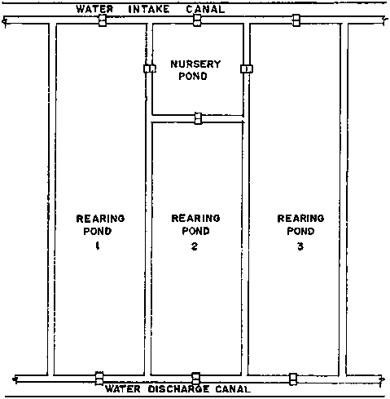
Fig. 4. Pond layout with one nursery pond, one transition pond, and one rearing pond (ASEAN/SCSP, 1978).
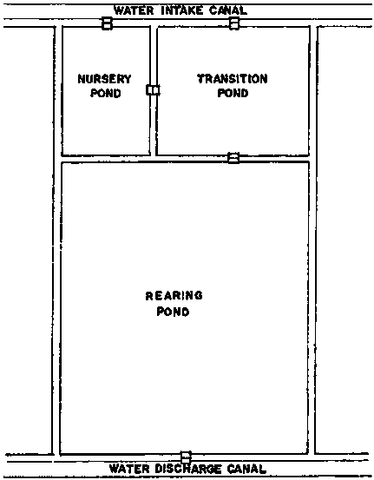
In general, however, shrimp monoculture uses direct stocking of post larvae in rearing ponds and therefore requires only one type of pond with separate inlets and outlets for better circulation and aeration.

4.3.4 Design of Pond Facilities
A fish pond system consists of the following basic components (Fig. 5):
(i) pond compartments enclosed by dikes;
(ii) canals for supply and drainage of water to and from the pond compartments; and
(iii) gates or water control structures to regulate entry and exit of water into and from the pond compartments.
Pond compartments are usually rectangular in shape although in Indonesia, running water ponds are generally triangular, raceway-shaped, or oval. They vary in size from less than a hectare to several hectares each, sometimes up to 20-50 ha in size. However, with the new intensive methods, the trend is to use smaller units for flexibility and ease of management.
The elevation of the rearing pond bottom for milkfish is usually such that only a maximum of 40 cm of water can be held in the ponds during the culture period (Jamandre and Rabanal, 1975). For new shrimp ponds, the minimum water depth is 1 m.
The entire pond system is enclosed by a perimeter dike and the individual pond compartments are separated from each other by partition dikes. The outer perimeter dike is usually wider and higher than the inner partition dikes and serves to protect the entire fish pond area from flooding and destruction brought about by tide and wave action. The inner dikes are narrower and shorter.
The design of the dikes depends primarily on soil characteristics. Dikes are usually earthen although intensive shrimp ponds are concrete-lined or brick-lined as in Taiwan (PC). The side slopes are designed for structural stability, the ratio of horizontal length to height ranging from 1:1 to 1:3 (Fig. 6). The height and width of dikes depend on the type (primary, secondary, or tertiary), tide conditions, flood level, pond water depth, soil shrinkage, and freeboard (SCSP, 1982a).
The following slopes are recommended for dikes built with good clay soil:
- 2:1 when dike height is above 4.26 m and exposed to wave action;
- 1:1 when dike height is less than 4.26 m and tidal range is greater than 1 m; and
- 1:2 when tidal range is 1 m or less, and dike height is less than 1m.
The dike crown should not be less than 0.5 m and the main dike surrounding the farm should be 0.5 m above the highest dike or flood level recorded in the locality (ASEAN/SCSP, 1978).
Fig. 5. Pond layout showing shrimp pond compartments, canals, and gates.
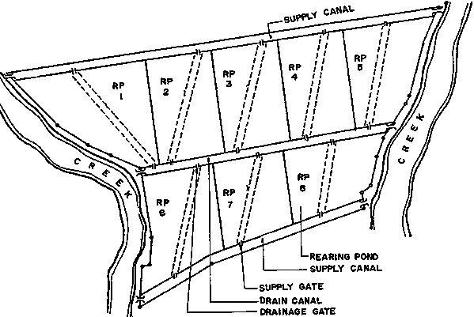
Fig. 6. Typical cross sections of dikes. (A)
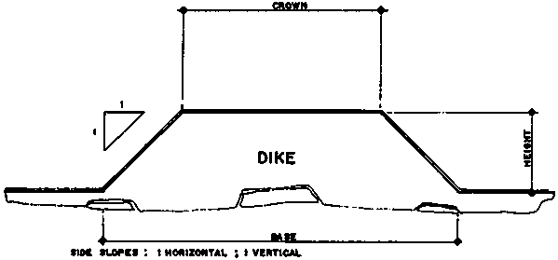
Fig. 6. Typical cross sections of dikes. (B)
Water conveyance structures (canals/channels) supply new water into the pond and drain out old water. They also provide the facility for holding and harvesting of fish and of serving as waterways for transporting farm supplies. Traditional milkfish ponds usually have only one canal that is used for both supply and drainage. Shrimp ponds have separate supply and drainage canals. Canals which are to be used for harvesting should be 30 cm below the level of the pond bottom to allow draining of pond water.
Having separate water intake and discharge canals in a pond complex brings about the following advantages (ASEAN/SCSP, 1978):
(i) Better filling and non-contamination of pond by discharge from other ponds.
(ii) Greatly reduced possibility of spread of disease.
(iii) Maintenance of constant head in intake canal thus reducing water loss through leaks/seepages in pond dikes and consequently reducing leaching of acids into the ponds from dikes with acid-sulphate soils.
(iv) Absence of conflict of usage between farmers.
(v) Better water exchange for individual ponds, and
(vi) Possibility of effecting flow-through systems.
The width of the canals depends on the amount of water they must carry. The following should be taken into account when designing canals:
(i) Volume of water to be held in the ponds.
(ii) Time requirement for filling or draining the pond.
(iii) Amount of rainfall which must be carried off in a given period of time.
(iv) Elevation of canal bottom in relation to tide.
(v) Other uses like transportation, harvesting of milkfish, and holding of broodstock (ASEAN/SCSP, 1978).
Diversion canals are constructed where there is much runoff from adjoining areas, to prevent sudden salinity changes and the possible entry of polluted, pesticide-loaded water and/or of silted water into the pond complex (Jamandre and Rabanal, 1975).
The entry and exit of water into ponds through the canals is regulated or controlled by gates. Main gates regulate the exchange of water between the pond system and the tidal stream or sea, and may be constructed of reinforced concrete (Fig. 7) or wood (Fig. 8). Reinforced concrete is more expensive but lasts longer. Such a gate has one or multiple (2, 3, 4, etc.) openings depending on the relative size of the pond unit to be served. A recent innovation for a smaller and less expensive main gate is the monk-type gate which uses culverts usually made of concrete hollow blocks (Fig. 9). The SEAFDEC Aquaculture Department has also introduced the open sluice gate made of ferro-cement (Fig. 10) (Corre, 1988).
Fig. 7. Main water control gate of reinforced concrete (from Jamandre and Rabanal, 1975). (A)
Fig. 7. Main water control gate of reinforced concrete (from Jamandre and Rabanal, 1975). (B)
Fig. 7. Main water control gate of reinforced concrete (from Jamandre and Rabanal, 1975). (C)
Fig. 8. Diagram of wooden gate (from Jamandre and Rabanal, 1975). (TOP VIEW)
Fig. 8. Diagram of wooden gate (from Jamandre and Rabanal, 1975). (FRONT END VIEW)
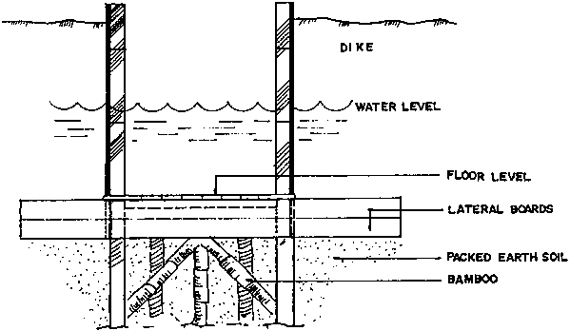
Fig. 9. Use of culvert pipes as secondary gates (from Jamandre and Rabanal, 1975). (A)
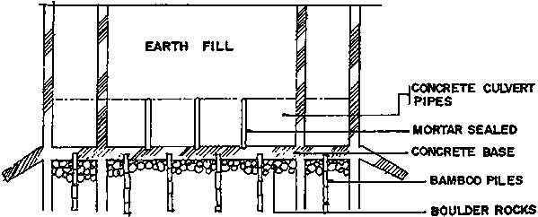
Fig. 9. Use of culvert pipes as secondary gates (from Jamandre and Rabanal, 1975). (B)
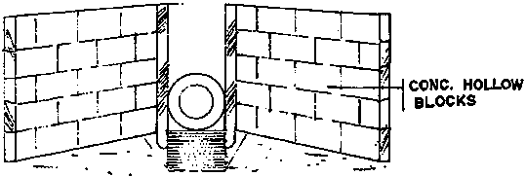
Fig. 9. Use of culvert pipes as secondary gates (from Jamandre and Rabanal, 1975). (C)
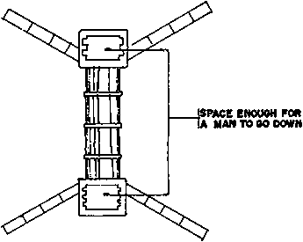
Fig. 10. Ferrocement culvert developed at the SEAFDEC Aquaculture Department (from Corre. 1988).
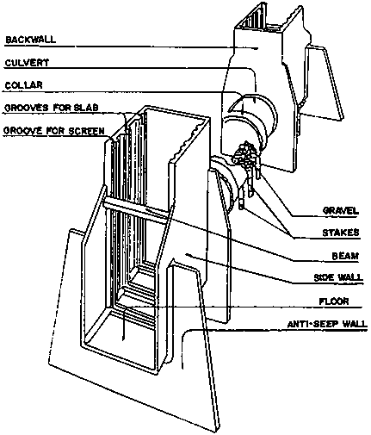
Secondary gates, which regulate water exchange between the ponds and the canals, are usually made of wood. Pipes or culverts can also be used for smaller ponds such as nursery or fry ponds and transition ponds for milkfish culture. Secondary gates are now usually located toward one end of the narrower side of the pond compartment to give good turbulence and circulation during the filling and draining.
Shrimp ponds are provided with separate supply and drainage gates to effect flow-through water management and facilitate water exchange through supply and drainage canals (NACA, 1986). Inlet and outlet gates are best located at opposite corners of the same pond (ASEAN/SCSP, 1978), across which a diagonal trench, about 5-10 m wide and 0.3-0.5 m deep, extending from inlet to outlet gates is recommended for convenient draining of water (Fig. 11) (Kungvankij et al, 1986).
Gates should be located where they are not exposed to strong weather forces and where water of good quality can be allowed to enter the fish pond system. Proper gate location can also serve to aerate the pond water and promote water circulation (SCSP, 1982a).
During the construction of gates for shrimp ponds a number of requirements should be kept in mind (ASEAN/SCSP, 1978), and the gates should:
(i) be durable, water-tight, and made of locally available materials;
(ii) have adequate capacity for the amount of water to be taken in or drained;
(iii) allow water to be taken in or discharged at the bottom;
(iv) have provisions for draining pond surface water;
(v) have gate bottom elevation that permits complete draining of pond water;
(vi) have slots or grooves for the placement of outside and inside screens to prevent undesirable species from entering the pond and the shrimps from leaving the pond;
(vii) have place for net installation for harvesting; and
(viii) be easy to operate.

4.3.5 Pond Management

4.3.5.1 Pond Preparation
4.3.5.2 Stocking
4.3.5.3 Feeding
4.3.5.4 Water Management
4.3.5.5 Pond Maintenance
4.3.5.6 Harvesting

Pond management techniques for finfish and shrimp culture, while varying slightly depending on the specific biological requirements of the culture organism, the type of culture system, and the culture environment (freshwater, brackishwater, and marine), are similar in that they involve the following basic activities:
(i) Pond preparation/conditioning.
(ii) Stocking.
(iii) Feeding and/or fertilization (depending on the culture system used).
(iv) Water management.
(v) Pond maintenance, and
(vi) Harvesting.
Fig. 11. Layout of improved shrimp pond showing diagonal trench extending from inlet to outlet (from Kungvankij et al., 1986).
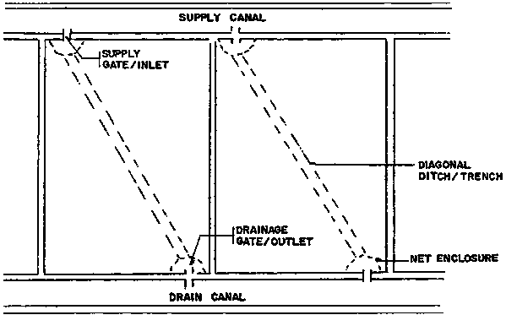
Variations would consist mainly of differences in application rates of fertilizers, lime, pesticides, and feeds; stocking rates and sizes of stocking material; rate of water change; and harvesting techniques (Table 8).
As discussed earlier in Section 4.2, extensively managed systems generally require the least management, with no supplemental feeding and minimal water exchange on account of the low stocking density used. On the other hand, intensively managed ponds require full artificial feeding and substantial water management to ensure optimum culture conditions for the species being reared.

4.3.5.1 Pond Preparation
Ponds are totally drained and the pond bottoms dried prior to the application of pesticides. Tobacco dust, derris root/rotenone powder, teaseed cake/powder, or Gusathion-A are used to eliminate predators and/or wild species that may eventually compete with the cultured organisms for food and space. Teaseed cake is perhaps the best fish poison to use in brackishwater ponds to selectively kill unwanted fish without damaging the shrimps and without affecting rotifers and copepods which are feed for shrimps. On the other hand, rotenone is most effective in fresh water and works better in low-salinity water (ASEAN/SCSP, 1978).
Ponds with acid-sulphate soils are repeatedly dried and flushed, i.e., filled and drained to remove the acids formed by pyrite oxidation. Agricultural lime is then applied to correct soil pH and bring it up to at least 6.5. Brackishwater ponds are usually treated by spreading 1.5 t of agricultural lime per ha, followed by another 1.5 t worked into the soil.
To stimulate and maintain the growth of natural plankton, organic (e.g., chicken manure) or inorganic fertilizer (e.g., urea, ammonium phosphate) are applied to the pond bottom. After fertilizer application, water is let in to a depth of about 20-40 cm and gradually increased to 1 m a week after fertilization. Intensively managed ponds or ponds where artificial feeding shall be given, do not need to be fertilized. Extensive ponds need regular fertilization during the culture period to maintain the growth of natural food. Semi-intensive ponds may use a mix of fertilization and supplementary feeding.
Table 8. Variations in pond management techniques commonly used for different species
Species | Stocking Rate | Fertilization | Feed Type | Rate of Water Change | Pesticides/Predator Control |  | Reference
 |  |  |  |  | Type | Application Rate
MILKFISH (Chanoschanos) | 2 000-  5 000/ha | 16-20-0 at 50 kg/ha;  45-0-0 at 15 kg/ha;  chicken manure at 0.5 t/ha twice weekly | Rice bran and trash fish as supplemental feed | Once every two weeks at high tide | Lime; ammonium sulfate | 1 t/ha  10 g/m² | Bombeo-Tuburan & Gerochi, 1988
TILAPIA (O. niloticus; O. mossambicus) | 5 000-  20 000/ha | Chicken manure at 500 kg/ha;  Inorganic fertilizers at 50 kg/ha | Rice bran, fish meal, ipil-ipil leaf meal |  |  |  | Camacho & Lagua, 1988
CATFISH (Clariasbotrachus and monocephalus) | 60-  300/m² |  | 9 parts trash fish and 1 part rice by-products | When necessary |  |  | Sirikul etal., 1988
PENAEIDS | From as low as 15 000 to as high as 300 000/ha | Chicken manure at 1-2 t/ha followed by inorganic fertilizer at 75-150 kg/ha mono-ammonium phosphate (16-20-0) and 25-50 kg/ha of urea (46-0-0) | Supplemental feed of rice bran with trash fish, mussels, and clam meat; artificial/formulated diets with 40% CP. | 20-30% once every week or every two weeks for low density ponds; 5-20% daily for semi-intensive to intensive ponds |  |  | Corre, 1988

4.3.5.2 Stocking
After the pond is prepared, fish fingerlings or shrimp post larvae are stocked at the appropriate density depending on the culture strategy, size of pond, and the size of fingerlings, among others.
The fingerlings are properly acclimated and conditioned prior to stocking and weak or diseased fish eliminated. Stocking is usually done in the early morning or late afternoon.

4.3.5.3 Feeding
Fish/shrimp grown in semi-intensive and intensive culture ponds are given supplementary and full artificial feeds, respectively, the former to augment the natural food in the pond, the latter to totally replace the natural organisms in the water as a source of nutrition.
A wide variety of feed ingredients is used to prepare supplemental/artificial feeds. The simplest fish feeds are prepared at the pond site using locally available raw materials like rice or corn bran, copra meal, and rice mill sweepings as sources of carbohydrates. These are usually mixed with animal protein like trash fish/fish meal, shrimp heads, and snail meat. Supplemental feeds for tilapia are prepared using 80% rice bran and 20% fish meal. Those for shrimps in improved extensive culture (low-density stocking but given dietary supplements for increased growth/production) usually include fresh raw materials like snail/mussel/clam meat or carabao hide and other slaughterhouse leftovers.
Commercial feed preparations are also available now in a wide range of brandnames, mostly for semi-intensive and intensive shrimp culture. (Taiwan (PC), Japan, and the USA are the top producers of commercial fish/shrimp feeds.) These commercial diets consist of a number of ingredients like fish meal, blood meal, bone meat, and shrimp head meal (to serve as attractant for the shrimp), together with vitamin and mineral premix and carbohydrate sources like rice/corn bran or wheat. The crude protein (CP) content of these shrimp feeds is generally not lower than 30% to satisfy the high animal protein requirement of shrimps, actually estimated to be about 40% during the earlier stages of growth.
Commercial feeds usually come in various formulations to match the protein requirement of the culture organism, which as a rule, decreases with age. Thus, fish/shrimp feeds come in different forms as starter, grower, and finisher, with starter feeds having the highest CP content of about 40% and finisher feeds having the lowest CP content of about 20%. Starter feeds are usually given on the first month of culture, finisher feeds on the last month, and grower feeds in between.
Some shrimp culturists prefer not to give artificial feeds during the first two weeks of culture when the newly stocked post larvae can subsist on the plankton available in the water.
The feeding rate is computed as a percentage of the estimated animal biomass in the pond, with higher rations given when the animals are small and gradually decreasing as they become bigger. The daily feeding rate usually starts at 5% and 10-15% of estimated biomass of fish and shrimps, respectively, and decreases to a low of 2% and 5%, for fish and shrimps, respectively, toward harvest.
The daily feed rations are given in equal portions during the course of a day. Freshwater fish like tilapia are usually fed twice a day - early morning and late afternoon. Penaeid shrimps are fed more frequently, from three to four to as often as six to seven times a day.
Feeds are broadcast into the water and/or supplied on feeding trays. In semi-intensive and intensive shrimp ponds, small feeding boats are used by caretakers who go around the pond distributing the feed by broadcasting. At certain points along the periphery of the pond, feeding trays (Fig. 12) are submerged into the water after known quantities of feed are put on the surface, to supply feed to the shrimps in the pond as well as to monitor feed consumption and shrimp growth. The feeding tray is lifted two to three hours after the feed was supplied to check how much of it has been consumed and to see if the shrimps are healthy and feeding. Empty feeding trays may indicate that the quantity given is inadequate and may have to be increased. Conversely, full or slightly touched trays indicate excessive feed quantities and/or sluggish shrimps. The feeding ration is subsequently adjusted accordingly to optimize feed utilization.
By monitoring the feeding tray, one can get a good indication of the sizes and quantity of shrimps present in the pond without a need for cast-netting or actual sampling, since shrimps are invariably found on the tray when it is lifted out of the water.

4.3.5.4 Water Management
Water in the pond is kept at certain levels for optimal fish growth. In general, a pond water depth of 1 meter is considered best for culture of tilapia, carps, and shrimps; traditional milkfish ponds can do with just 40-60 cm of water.
Pond water is not just maintained at a certain depth; its quality must also be kept high to ensure optimal growth of the culture organism. This is particularly important in semi-intensive and intensive culture systems where large amounts of metabolites are continously excreted into the pond and where excess, unconsumed feeds add to the bottom load and serve to pollute the water.
To prevent the deterioration of the pond environment, pond water is continuously freshened by the entry of new water from the river or water source (through the supply canal) while old water is drained through the outlet/drainage gate and through the drainage canal into the sea or river.
A flow-through system of water management that allows the simultaneous entry and exit of water into and out of the pond is essential in any high-density culture system. This is effected by the provision of separate inlets and outlets for all the ponds, each inlet regulating the flow of water from the supply canal to the pond and each outlet controlling the discharge of water out of the pond into the drainage canal. Both the supply and drain gates are so designed as to bring water into and drain water out of the lower levels of the pond, where water quality tends to get poorer faster as a result of the accumulation of wastes and their subsequent decomposition.
Fig. 12. Feeding tray.
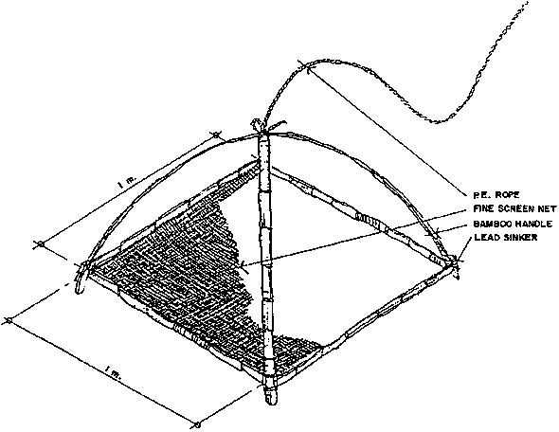
The regular replenishment of pond water, independent of natural tidal fluctuations, is made possible by the use of pumps which draw water from the source even at low tide. Although there is no hard-and-fast rule as to the rate of water change necessary for medium- to high density aquaculture, semi-intensive culture systems usually change water at the rate of 10% daily for an equivalent total replacement of water every ten days or three times per month. Intensively managed ponds require greater water exchange in view of the much higher organic load on the pond bottom, especially toward the latter part of the culture cycle when the animals excrete more wastes.
Intensive ponds/tanks usually need to provide for aeration facilities/equipment to prevent anoxia that may lead to mass mortalities. Oxygen depletion in high-density ponds results not only from the faster rate of utilization of dissolved oxygen for respiratory activities; it is also caused by the fast rate of decomposition at the pond bottom by aerobic or oxygen-consuming micro-organisms.
Paddlewheels or other types of aerators are thus provided in the ponds to effect the infusion/introduction of greater quantities of oxygen into the water and prevent fish/shrimp mortalities. The aerators are usually operated at regular/periodic intervals for certain fixed durations during the day but especially in the early morning hours when the concentration of dissolved oxygen is known to be lowest (as a result of the absence of photosynthetic, oxygen-producing activity in the pond). Toward the end of the culture period when oxygen demand is highest, aeration may have to be provided continuously and not just sporadically as could be done during the initial stages of rearing. At that time too, water pumps usually need to be run for longer periods to effect greater water exchange.
Pond water is also regularly sampled and measurements taken of basic/essential parameters, particularly dissolved oxygen, pH, and salinity. This is important for the purpose of determining the need for corrective/remedial action to bring water quality to optimum levels and obtain good yields.
Dissolved oxygen levels are kept, as much as possible, above 5 ppm by pumping and aeration. Problems of acidity are corrected by liming. Salinity is an important parameter for penaeid culture and has to be maintained within a range of 15-25 ppt for best results. During summer months, high-salinity water can be diluted by mixing with fresh water from springs or deep wells.

4.3.5.5 Pond Maintenance
(i) Fertilization
Aside from feeds and water management, the following pond maintenance procedures are carried out: regular application of fertilizers, lime, and pesticides; prevention of entry of predators; monitoring of the stock for growth rate determination as a basis of feeds and water management; and regular pond upkeep and maintenance.
Extensive ponds are fertilized regularly using either organic fertilizers like chicken, cow, or pig manure, or inorganic fertilizers like urea, ammonium phosphate, or both, to maintain the plankton population in the pond. The fertilizers are either broadcast over the pond water surface or kept in sacks suspended from poles staked at certain portions along the pond periphery. Semi-intensive and intensive culture systems do not require fertilization since they are not natural food-based, except for those which grow plankton-feeders like milkfish whose diet is largely algae dependent.
(ii) Liming
In addition to fertilization, ponds also need to be given regular doses of lime to maintain water pH at alkaline or near-alkaline levels (preferably not lower than six). Agricultural lime is broadcast over the pond and applied on the sides of the dikes to correct soil and water acidity.
(iii) Elimination of Pests and Predators
Unwanted and predatory species which may have survived the application of pesticides during pond preparation or which were able to enter the pond through the gate screens or through cracks in the dikes, are eliminated by the application of pesticides, preferably organic, into the pond.
Crabs, which are a serious problem in shrimp ponds because they are carnivorous and cause damage to the pond dikes, are not usually affected by known pesticides and are therefore best eliminated by the use of crab traps situated in the pond.
It is also important that the gates are properly screened and the screens kept whole, to prevent the entry of small unwanted fish into the pond. Double screens are usually installed at the main intake to ensure that pests and predators are prevented from entering the pond system.
(iv) Stock Monitoring
The culture organisms are monitored closely and regularly to determine their rate of growth and the general condition of the stock. They are regularly sampled for length-weight measurements as a basis for determining/estimating their biomass in the pond and therefore their daily feed rations, as well as for making projections on harvest schedules and procurement of pond inputs.
In the first few months of culture, the feeding tray is a good tool for stock monitoring, as explained in Section 4.3.5.3. As the organisms grow in size, cast-netting is used as a sampling tool, with those caught in the throw of the cast net providing an indication as to sizes and weights of stock. Based on the sampled weights and the daily feed consumption, it is possible to predict the available biomass (i.e., stock surviving after initial mortalities) and make projections on volume of harvest. For this purpose, it is essential that accurate records are kept for analysis at a later time. Data on initial size/weight and number of fry/post larvae stocked, average body weight at each sampling, and feed consumption on a daily basis, are important to have on file.
(v) Regular Upkeep and Maintenance of Facilities
The pond dike and gates are checked regularly for cracks that could lead to seepages and losses of stock. The dikes are best planted with grass or vegetative cover to prevent erosion. The gates and other support infrastructure are properly maintained for efficient operation.

4.3.5.6 Harvesting
Marketable-size fish/shrimps are harvested at the end of the culture period by draining the pond and using harvesting nets to catch the fish or shrimps. The latter are harvested with a bag-net attached to the sluice gate as water is drained out of the pond at low tide. Tilapia are harvested using seine nets after the pond water is drained to half-level the night before.
Harvest of milkfish takes advantage of their behaviour of swimming against the current. The method, known in the Philippines as "pasulang" or "pasubang" involves draining 85-90% of the pond water during low tide and allowing in the water at the incoming high tide so that the fish swim against the current through the tertiary gate and into the catching pond, whose gate is closed once a large number of fish is impounded. The fish in the catching pond are then harvested by seining and the rest hand-picked.

4.4 Integrated Fish Farming
In a number of countries in Asia (e.g., China, Nepal, Thailand, Malaysia, Indonesia) and in some parts of Africa, freshwater fish culture is integrated with the farming of crops, mainly rice, vegetables and animals (usually pigs, ducks, and chickens). This leads to greater overall efficiency of the farming system as wastes/by-products or one component are used as inputs in another. For example, poultry or pig manure can be used to fertilize the fish pond and the vegetable garden and the waste vegetables can be fed to the fish and the pigs (Fig. 13).
In Africa, fish culture in rice fields and in combination with pig and duck rearing, is not too widely practised but has significant potential. Reported fish yields ranged from 2 000-4 000 kg/ha/y with ducks, 8 500-8 900 kg/ha/y with pigs, and 3 600-4 900 kg/ha/y with poultry in Gabon. It has also been proven economically viable since it involves minimal investment. Its spread has, however, been constrained by the widespread use of pesticides in many countries (Satia, 1989).

4.5 Pen and Cage Culture

4.5.1 Culture Species
4.5.2 Site Selection
4.5.3 Design and Construction
4.5.4 Pen and Cage Operation

Pen and cage culture involve the rearing of fish within fixed or floating net enclosures supported by frameworks made of bamboo, wood, or metal, and set in sheltered, shallow portions of lakes, bays, rivers, and estuaries.
Compared to fish pond culture with its 4 000-year tradition, fish pen/cage culture is of more recent origin. Cage culture seems to have developed independently in at least two countries - in Kampuchea where fishermen in and around the Great Lake region would keep Clarias spp. and other commercial fishes in bamboo or rattan cages and baskets; and in Indonesia where bamboo cages have been used to grow Leptobarbus hoeveni fry as early as 1922. Since then, cage culture has spread throughout the world to more than 35 countries in Europe, Asia, Africa, and the Americas (Beveridge, 1984).
Fig. 13. Diagram showing interrelationships among the various components of an integrated fishfarming system.
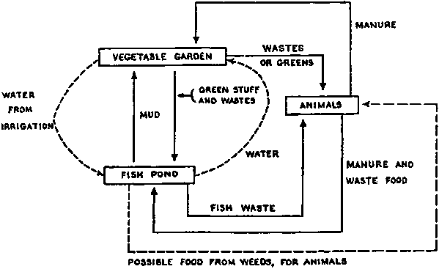
Pen culture is said to have originated in the Inland Sea area of Japan in the early 1920s (Alferez, 1977), adopted by the People's Republic of China in the 1950s for rearing carps in freshwater lakes (Beveridge, 1984), and introduced to culture milkfish in the shallow, freshwater, eutrophic Laguna de Bay in the Philippines in the 1970s (Baguilat, 1979). From there it has been successfully extended for the culture of tilapia and carps (Rabanal, 1988b). Its development and adoption as a popular technology has not been widespread, though, perhaps because of its site-specific requirements like its suitability mainly in shallow lentic environments. At present, it is commercially practised only in the Philippines, Indonesia, and China (Beveridge, 1984).
The wider popularity of cage culture as compared to pen culture may be due to its greater flexibility in terms of siting the structures. For example, cages may be installed in bays, lagoons, straits, and open coasts as long as they are protected from strong monsoonal winds and rough seas. Floating cages can also be set up in deep lakes and reservoirs, and in rivers and canal systems, and even in deep mining pools which could not be used otherwise for culture due to harvesting difficulties (Chua, 1979 and Gargantiel, 1982).
In general, however, both pen and cage culture have expanded rapidly, especially over the past two decades vis-a-vis the decreasing availability of land-based resources for fish culture and an increasing awareness of their merits over traditional pond culture, such as:
(i) their applicability in different types of open water bodies like coastal waters, protected coves and bays, lakes, rivers, and reservoirs;
(ii) their high productivity (of as much as 10-20 times that of ponds Of comparative sizes) with minimal inputs and at lower costs to develop and operate; and
(iii) the greater socio-economic opportunities they provide to low-income families in the rural areas, particularly those displaced by the reduction of fish catches in over-exploited coastal, municipal waters, because they require comparatively low capital outlay and use simple technology.
Yields from pen and cage culture are generally high, with or without supplemental feeding depending on the natural productivity of the water body. In the Philippines, for example, the yields of milkfish from fish pens in Laguna de Bay were as high as 4 t/ha/crop (compared to a national milkfish fish pond average of 1 t/ha/y in 1980 when the productivity of the lake was very high at 1 700 mg C/m³/hr (Baluyut, 1983).
In Indonesia, the cage culture of common carp in the Lido Reservoir in Cigombong gave a total production of 28 kg/m² at a stocking density of 6 kg/m² (Baluyut, 1983). The cage culture of marine finfishes has likewise been shown to give high yields (Table 9).

4.5.1 Culture Species
The choice of species for stocking and rearing in pens and cages is governed by much the same criteria as in species selection for pond culture, including (Guerrero, 1982):
(i) fast growth in confinement;
(ii) good consumer acceptance;
(iii) high tolerance to a wide range of environmental conditions;
(iv) resistance to disease;
(v) ready supply of fish seed for stocking; and (vi) ease of culture and management.
Table 9. Comparison of production of cage-cultured marine fish
Species |  | Seriola T: quinqueradiata | Trachinotus carolinus | Polydactylus sexfilis | Epinephelus salmoides*
Country of culture |  | Japan | Florida, USA | Hawaii, USA | Penang, Malaysia
Initial stocking density
 | fish/m³ | 10 | 250 | 50 | 60
 | kg/m³ | 0.15-0.55 | 1.75 | 0.4 | 3.4
Rearing period (days) |  | 225 | 273 | 300 | 240
Production (kg/m³) |  | 0.85-14.45 | 44.7 | - | 41.4
Average production rate (kg/m³/day) |  | 0.004-0.06 | 0.16 | - | 0.17
Mean size of fish
 | Initial (g) | 10-50 | 7 | 9 | 55.7
 | At harvest (g) | 1 000-2 000 | 213.6 | 300 | 795.9
Average growth rate (g/fish/day) |  | 4.40-8.67 | 0.76 | 0.97 | 3.08
*Based on existing commercial culture.
Source: SEAFDEC/IDRC, 1979
There are approximately ten species of fish which are commercially cultured in cages and pens in both temperate and tropical waters, including tilapias (S. mossambicus and S. niloticus); carps (Chinese, Indian, and common varieties); milkfish; snakeheads and catfishes; marble goby; and salmonids (rainbow trout, salmon). Marine species include mainly grouper, sea bass, mullet, snapper, and milkfish (Table 10).
In the Philippines, Indonesia, and China, pen culture is limited to the following species: milkfish (Chanos chanos); tilapia; and the Chinese carps: bighead (Aristichthys nobilis), silver carp (Hypophthalmichthys molitrix), grass carp (Ctenophanyngodon idella); and common carp (Cyprinus carpio).
Other species have been suggested as possible candidates for utilization in pen/cage culture in the following three different environments (SEAFDEC/IDRC, 1979):
(i) Freshwater
Habitats with high natural productivity (e.g., lakes, oxbow lakes, swamps, mining pools, rivers, and reservoirs): mullets, eels, catfish, Puntius gonionotus.
Habitats with low natural productivity: Leptobarbus, Clarias batrachus, Oxyeleotris, and Macrobrachium.
(ii) Brackishwater
Sea bass, mullet, siganids, sea bream, grouper, snapper, threadfin, carangids. Hilsa spp., Sparus spp., and eels.
(iii) Marine
Siganids, pampano, yellowtail, tuna, grouper, snapper, sea bass, sea bream, carangids, pomfret.

4.5.2 Site Selection
The selection of sites for fish pen/cage culture should be guided by the following basic criteria (Felix, 1982; Mane, 1982; and Chua, 1979):
Table 10. Commercially important species in inland water cage and pen farming
Species |  | Countries | Climate | Type of feeding | Lotic/Lentic | Cage/Pen
Salmonids | Rainbow trout | Europe, North America, Japan, high altitude tropics (eg Colombia, Bolivia, Papua New Guinea) | Temperate | Intensive. High protein (40%) | Lentic | Floating cage
 | Salmon (various species) smolts | Europe, North America, South America, Japan | Temperate | Intensive. High protein (452) | Lentic | Floating cage
Carps | Chinese carps (Silver carp, grass carp, bighead carp) | Asia, Europe, North America | Temperate -tropical | Mainly semi-intensive, although also extensive (Asia) and intensive (Europe North America) | Lotic and lentic | Cages and pens
 | Indian major carps (Labeo rohita) | Asia | Sub-tropical -tropical | Semi-intensive | Mainly lentic | Mainly cages
 | Common carp | Asia, Europe, North America, South America | Temperature -tropical | Mainly semi-intensive, although also intensive | Mainly lentic | Mainly cages
Tilapias | (O. Mossambicus, O.niloticus, etc.) | Asia, Africa, North America, South America | Sub-tropical -tropical | Mainly semi-intensive, although also intensive | Mainly lentic | Mainly cages
Catfishes | Channel catfish | North America | Temperature -sub-tropical | Intensive | Lentic | Floating cages
 | Clarias spp. | Southeast Asia, Africa | Tropical | Semi-intensive | Lotic and lentic | Floating cages
Snakeheads | Channa spp. Ophicephalus spp. | Southeast Asia | Tropical | Semi-intensive/intensive | Lotic and lentic | Floating cages
Pangasius spp. |  | Southeast Asia | Tropical | Semi-intensive | Lentic | Floating cages
Milkfish |  | Southeast Asia | Tropical | Semi-intensive | Lentic | Pens
Source: Beveridge, 1984
(i) Protection from high winds or typhoons.
(ii) Adequate water exchange that will enable the flow of nutrient-laden water through the pens/cages.
(iii) Good water quality (high or adequate dissolved oxygen, stable pH, and low turbidity, and absence of pollution).
(iv) Firm bottom mud to allow pen framework to be driven deep into substrate for better support.
(v) Freedom from predators and natural hazards.
(vi) Accessibility to sources of inputs, including labour and markets, and
(vii) Good peace and order condition.
The factors to be considered in selecting sites for pens and cages in freshwater, brackishwater, and marine environments are shown in Table 11. It is important to note that the selection of a suitable site is vital to the success of the culture system; a good site selected solves much of the management problems of pen/cage culture (Chua, 1979).

4.5.3 Design and Construction
Both fish pens and fish cages are built around the same basic design concept: a net enclosure supported by a rigid framework. They differ, however, in a number of respects. Firstly, a pen does not have a net bottom; the edges of its net wallings/fencings are anchored to the lake bottom/substrate by means of bamboo pegs and the lake bottom is the pen bottom (Fig. 14). In comparison, a cage is like an inverted mosquito net with the cage bottom made of the same netting material used for its four sides (Fig. 15).
Secondly, fish pens theoretically have no limit to their size/area while cages cannot exceed 1 000 m² in area for reasons of the quantity of material required for cage construction (due to the need for a flooring) and manageability of operation (cages have to be lifted and the fish scooped out and not harvested using nets as in pens).
Thirdly, design of the structures and methods of construction are different. Fish pens are fixed structures; fish cages may either be fixed or floating. Fish pens for milkfish culture in Laguna de Bay, Philippines consist of a nursery pen within the grow-out pen/enclosure (Fig. 16). Cages are individual units for either seed production or grow-out; they are, however, usually installed in clusters or modules with a common framework (Fig. 17).
Pens and cages come in various shapes and sizes and are made of different types of materials. Most pens and cages are rectangular or square although some may be circular, as in some milkfish pens in Laguna de Bay and the milkfish broodstock cages at the SEAFDEC Aquaculture Department in the Philippines (Fig. 18), or cylindrical as those used for fish collection in Malaysian or Indonesian fresh waters (Fig. 19). Rectangular cages are preferred for easy operation and management. Circular cages are more suitable for some species like milkfish and yellowtail but are more expensive to build (SEAFDEC/IDRC, 1979).
Table 11. Factors to be considered in the selection of cage/pen sites
 | Marine |  | Brackishwater |  | Freshwater
Protection from Elements
Natural | Wind direction |  | Water current |  | Wind direction
 | Lagoons, bays and coves offer |  | Erosion and |  | Water current
 |  | differing |  | accretion | Floods
 |  | situations |  | siltation | Typhoons
Artificial | Breakwaters |  | Deflectors |  | Breakwaters
Water Circulation
Related to protection | Currents |  | Currents |  | Currents
 | Tidal levels |  | Tidal levels |  | Stratification and up-welling
Net pen spacing | Well-spaced |  | Well-spaced |  | Well-spaced
Water Quality and Soil Type
Chemical | Salinity |  | Salinity |  | Soil type
 | Type of bottom |  | Type of bottom |  | pH, NH3, BOD, hardness
 |  |  | Pesticides and fertilizer run-off |  | Saltwater intrusion
Physical | Temperature |  | Temperature |  | Temperature
 | Siltation and turbidity |  | Siltation and turbidity |  | Siltation and turbidity
 | Tidal fluctuation |  | Tidal fluctuation |  | Depth fluctuation
 | Topography |  | Topography |  | Texture of the substratum
 |  |  | Floating objects |  | Topography
 |  |  |  |  | Floating objects
Biological | Predators, pests and competitors |  | Predators, pests and competitors |  | Algal bloom
 | Vegetation |  | Vegetation |  | Predators, pests and competitors
 | Plankton bloom |  | Plankton and benthos |  | Vegetation
 | Diseases and parasites |  | Diseases and parasites |  | Diseases and parasites
 |  |  |  |  | Natural productivity
Pollution | Industrial pollutants |  | Industrial pollutants |  | Industrial pollutants
 |  |  |  |  | Thermal pollution
 | Domestic pollutants |  | Domestic pollutants |  | Agricultural pollutants
 | Agricultural pollutants |  | Agricultural pollutants |  | Mine pollution
Access and Security
Supplies | Materials |  | Materials |  | Materials
 | Feeds |  | Feeds |  | Feeds
 | Fingerlings |  | Fingerlings |  | Fingerlings
Markets (live and fresh sales) | Close to market |  | Close to market |  | Close to market
Labor | Availability |  | Availability |  | Availability
 | Cost |  | Cost |  | Cost
Monitoring | Easy access necessary for regular monitoring visits.
Security | Efficient precautions and security from interference of all sorts.
Others | Frequency of navigation |  | Frequency of navigation |  | Frequency of navigation
 | Property rights, policies and laws |  | Property rights, policies and laws |  | Property rights, policies and laws
 | Social aspects |  | Social aspects |  | Social aspects
Source: SEAFDEC/IDRC, 1979
Fig. 14. Indicative design of a fishpen wall showing how it is anchored on the lake bottom. (A)
Fig. 14. Indicative design of a fishpen wall showing how it is anchored on the lake bottom. (B)
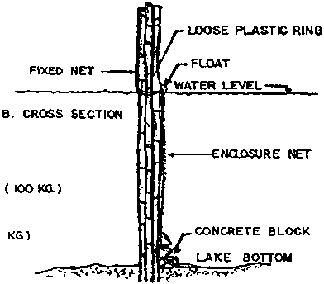
Fig. 15. Perspective view and parts of a floating cage. (A)
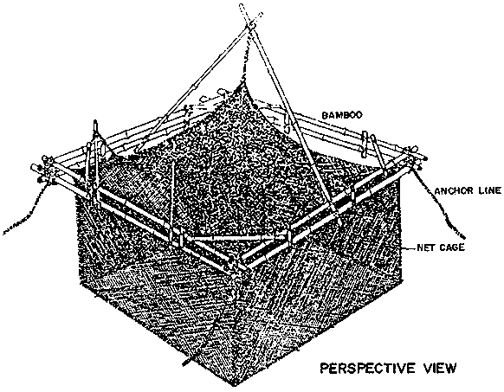
Fig. 15. Perspective view and parts of a floating cage. (B)
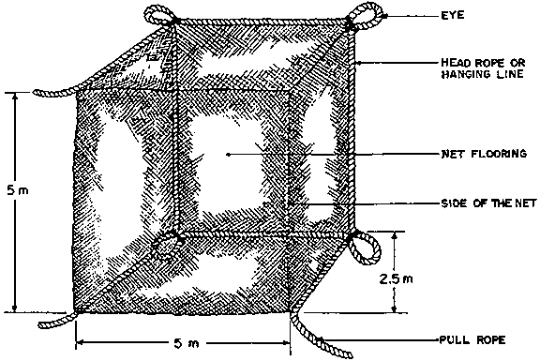
Fig. 16. Perspective of a fishpen showing nursery pen within the grow-out enclosure.
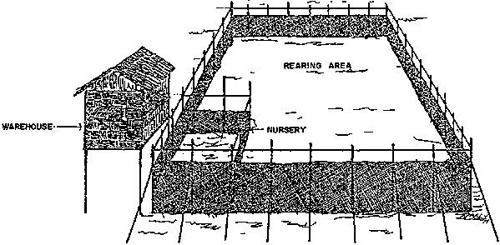
Fig. 17. Cluster/module of fish cages.
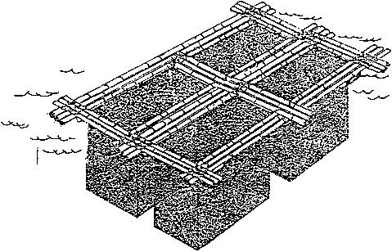
Fig. 18. Circular milkfish broodstock cage used at the SEAFDEC Aquaculture Department (from Yu et al, 1979).
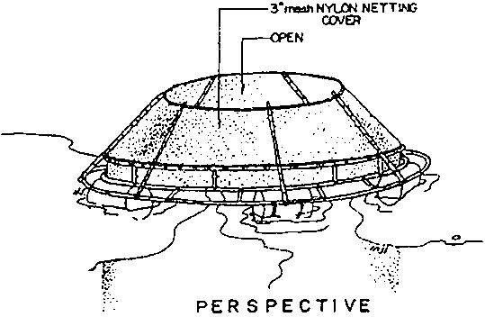
Fig. 19. Cylindrical fish cage made of bamboo and rattan (from Watson and Tingang Raja, 1979).
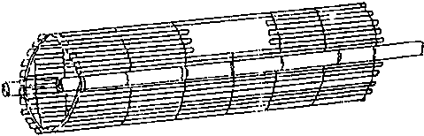
Polyethylene and nylon monofilament twine are widely used for fabricating cages and net pens although wire mesh is used in several countries. The framework structure is generally made out of bamboo and other locally available wood. Cage floatation materials include bamboo, PVC pipes/containers, steel or plastic drums, styrofoam, and aluminum floats. The type of anchor for floating cages varies depending on the depth of water, nature of bottom, tides, and currents. Concrete slabs of different sizes and shapes, sand bags, and iron anchors are widely used in different countries (Fig. 20).

4.5.4 Pen and Cage Operation
Basic procedures involved in the management of pen and cage culture are very much like those in pond culture, starting with completion of construction and preparation of the culture facilities for stocking, rearing, and harvesting. Slight variations in specific activities exist, however, as the result of the very nature of the system. For example, it is obviously not possible to apply fertilizers, lime, and pesticides since the system has open water exchange between the inner compartment and the outside environment.
Soon after construction of the pen/cage is completed, preparations are made to procure fry/fingerlings for stocking. Milkfish pens have a nursery compartment into which milkfish fry are grown for 3-4 weeks to 12 cm long fingerlings which can be released into the grow-out compartment.
The nursery pen and the grow-out compartment are prepared for stocking by clearing the bottom of predatory fish like Megalopscyprinoides and Elops hawaiiensis. The milkfish fry/fingerlings from the nursery pen are stocked in the rearing pen at 20 000-50 000 per ha where they are cultured to marketable size.
In the Philippines, the milkfish stock in the pen is not generally given supplemental feeding except for occasional rations of bread crumbs, rice bran, broken ice cream cones, fish meal, and ipil-ipil leaf mill.
On the other hand, cage-reared fish may or may not be fed supplemental or artificial diets depending on the stocking density used and the level of technology in the country. Cage feeding trials in the Philippines showed the adequacy of a ration composed of 77% rice bran and 23% fish meal with feed conversion ratios of 2.2-2.8. Current feed practices in freshwater cage culture involve the provision of supplemental feeds using readily available ingredients like rice bran and poultry feeds. Other countries use artificial feeds based on simple diets (Table 12) preferably prepared in pelleted form for best results.
At the end of the culture period, the fish are harvested from pens using harvesting nets (e.g., gill nets, cast nets, seines) or from cages by lifting the cage and causing the fish to collect in one corner for scooping out using a pail.
Fig. 20. Types of anchor used for floating cages (from SEAFDEC/IDRC, 1979). (A)
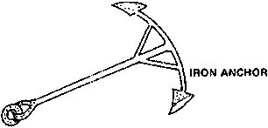
Fig. 20. Types of anchor used for floating cages (from SEAFDEC/IDRC, 1979). (B)
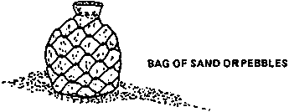
Fig. 20. Types of anchor used for floating cages (from SEAFDEC/IDRC, 1979). (C)
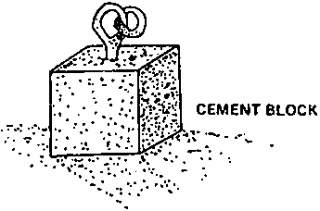
Fig. 20. Types of anchor used for floating cages (from SEAFDEC/IDRC, 1979). (D)
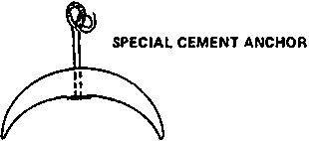
Fig. 20. Types of anchor used for floating cages (from SEAFDEC/IDRC, 1979). (E)
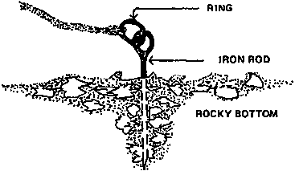
Table 12. Feed types given to cage-reared fish
Country | Culture Species | Feed Type | Reference
GDR | Common carp | Formulated feed/pellets, 33.7% CP | Muller, 1979
USSR | Common carp | Mixture of minced trash fish, molluscs, crayfish, and grown cereals | - do -
Hungary | Wels (Silurens glanis) | Trash fish, slaughterhouse wastes, cereal grain meals | - do -
-do- | Carp polyculture (common, silver, bighead) | Pelleted common carp feed
India | Indian carp polyculture | Soya bean powder, ground nut, oil cake, rice polish (1:1.1) | Natarajan et al., 1979
Indonesia | Leptobarbus hoeveni and Thynnichthys thynoides | Coconut water, cassava, rubber leaves | Reksalegora, 1979
Indonesia | S. niloticus | Aquatic plants (Lemna, Hydrila, Chara) | Rifai, 1979
Nepal | Common carp | Wheat flour, rice bran, mustard oil cake | Sharma, 1979
Thailand | Catfish, sand goby, common carp, local carp, tilapia, snakehead | Pellets consisting of ground fish meal, soy bean, peanut, and rice bran | Tangtrongpiros, 1979
 | Sea bass (Lates calcarifer) | Trash fish | Dhebtaranon et al., 1979

4.6 Open Water Culture

4.6.1 Mollusc Culture
4.6.2 Seaweed Farming

The farming of molluscs and seaweeds in open marine waters has become increasingly popular in a number of countries, especially in the Third World where it is seen as a viable alternative to municipal or artisanal fisheries or as a means of supplementary income for small-scale fishermen. Because seafarming is generally low-cost and labour-intensive and could thus involve entire coastal communities, it is particularly appropriate in areas where production from municipal fisheries has substantially declined and where, as a result, subsistence fishermen have little or no means of livelihood.

4.6.1 Mollusc Culture
Bivalves are widely cultured in a number of countries world-wide. In Asia and the Pacific, they represent a high quality food resource with annual production higher than from crustacean culture on a per hectare basis (Sitoy, 1988). In 1984, molluscs accounted for approximately 35% of the total production of coastal aquaculture in terms of gross weight in the region (Shang, 1986).
The most important species for culture in Southeast Asia are the oysters (mainly Crassostrea spp.), mussels (mainly Perna spp.), clams, cockles, and scallops (Pagcatipunan, 1987; Sitoy, 1988; Cheong, 1988; Liong et al., 1988).
In Japan, the most commonly cultured species include Crassostrea gigas, C. rivularis, C. nippona, C. echinata, and Ostreadenseramellosa, with C. gigas as the predominant species (Honma, 1980). In Africa, the culture of Venerupis is reported in Tunisia and Pinctada spp. in Sudan (Shehedah, 1975). In Mexico, the culture of the large oyster Crassostrea spp. is carried out by cooperative societies and of the mussel Mytilus edulis on floating rafts by private investors.
Oysters are widely distributed in estuaries and bays which receive some run-off from land and have somewhat lower salinity than the open sea. As they filter their food from the water, they grow best in areas with moderate to high concentrations of phytoplankton (SCSP, 1982c). Oysters grow best in intertidal areas where they are exposed for some minutes or a few hours during low tide (Pagcatipunan, 1987). Mussels, on the other hand, cannot tolerate tidal exposure even during low tide.
The best sites for culturing molluscs are therefore those that meet their biological requirements, including the following:
(i) Seawater salinity range of 15-35 ppt.
(ii) Water depth of 1-10 m, and
(iii) Muddy bottom for mussels and hard rocky or coralline substrates for oysters.
In addition, the area for mollusc culture should be protected from strong water currents reaching three knots and should be accessible to source of seed, transport, and markets. Furthermore, the presence of local available stock in an area is a good indicator of its suitability for mollusc culture.
Countries which have successfully cultured bivalve molluscs have developed their own systems of culture which depend entirely on natural seed stock, which are either gathered from natural seed beds or collected using suitable materials for collecting seed from natural grounds (Sitoy, 1988).
In the Philippines, both natural and synthetic ropes have been used for spat collection. However, since natural ropes, which have been found to attract more larvae than synthetic polyethylene or polypropylene ropes, do not last long, natural fibrous materials like coconut coir are sometimes interwoven with synthetic nylon ropes to make them more attractive to the larvae (Yap et al., 1979; Sitoy et al., 1983).
The string seed collectors are submerged in the sea water for seed collection at the right time. They are hung on a collector rack, normally 12 strings along a distance of 1.8 m to hold about 1 000 shells. Sometimes, strings are hung separately from each other at regular intervals; at others, three or four strings are put together for hanging to prevent branches from attaching to strings when they occur in large quantities (Fig. 21) (Honma, 1980).
Three principal methods of oyster culture are used in the Philippines and Japan: (i) hanging method including rafts, longlines, simple hanging, and rocks; (ii) stake or stick method; and (iii) broadcast or sowing method (SCSP, 1982c; Honma, 1980).
In Japan, the earliest method used at the Hiroshima Prefecture, where oyster culture began in the 17th century, was the stick culture method. In 1927, the hanging method of culture was introduced which later developed into different variations, viz., the simple hanging method, raft method, and longline method, to suit different local conditions as culture grounds shifted from inner to outer parts of the bay to outer open seas (Honma, 1980).
The broadcast system is actually used throughout the world in places where the bottom of shallow bays is firm enough to support the materials used as collectors and for growing oysters. Oyster shells, stones, or other hard objects are scattered on the bottom in areas where setting or the attachment of oyster larvae is known to occur. The young oysters or spat are left in places attached to the collectors until they are large enough for harvest (SCSP, 1982c).
The stake method is usually applied in shallow areas with soft or muddy bottom, usually not more than 1 m deep during low tide. The stakes, usually bamboo trunks (whole or split), branches of mangrove trees, or concrete Y-shaped posts and other similar materials are staked on the sea bottom in rows spaced about 0.5 m apart, to serve as attachment for oyster spat.
The hanging method of oyster culture uses empty oyster shells or other material such as coconut shells as collectors. The collectors are strung on synthetic twine or heavy monofilament nylon, and placed about 10 cm apart by using bamboo tubes as spacers or by tying knots in the twine. The strings are hung from a platform or rack/tray made of bamboo or wooden splits or welded wire with wooden frame, and placed on wooden plots. Oysters detached from the collectors or those small oysters/seedlings which are separated from harvested stocks are cultured on the trays until they are big enough for the market (SCSP, 1982c; Pagcatipunan, 1987).
Fig. 21. String seed collectors for mollusc spat (from Honma, 1980).
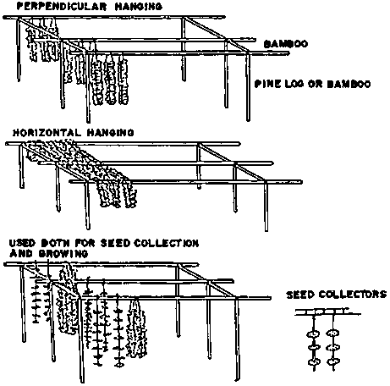
Harvesting procedures vary with the culture method. Oysters grown on stakes or by hanging are removed from the stakes or ropes on shore or in a boat after the stakes/ropes are lifted out of the water. Those grown by broadcasting are usually collected at low tide (SCSP, 1982c).
Mussel farming makes extensive use of bamboos either as stakes or as floating rafts. The stake method, similar to that for oyster culture, is the most commonly used. The mussels are harvested by divers after 6-10 months when they reach a length of 5-8 cm.
Alternatively, mussels are grown on floating rafts (Fig. 22) which have the following advantages: (i) faster growth; (ii) possibility of regular thinning and therefore higher production per unit area; (iii) possibility of transfer to other areas to prevent siltation; and (iv) ease of construction using more durable materials (Sitoy, 1988).
Mussels and oysters grown in waters contaminated by domestic and industrial wastes need to undergo depuration or cleansing, using artificially cleaned water or clean seawater from saltwater wells, to ensure satisfactory microbiological and chemical quality of the product. The depuration process flow and schematic diagram of a shellfish purification plant are shown in Figure 23.

4.6.2 Seaweed Farming
Seaweeds, aside from being used as food, are important sources of colloids or gels, such as agar, as well as minerals of medicinal importance such as iodine. Eucheuma, a red algae, is a valuable source of carrageenan, an important industrial compound used in stabilizing and improving the quality of a great number of products. Caulerpa lentillifera, a green algae, is economically important because it is a favourite and nutritious salad dish containing essential trace minerals such as calcium, potassium, magnesium, sodium, copper, iron and zinc. It is also known for its medicinal properties, being used as an anti-fungal agent and as a natural means for lowering blood pressure. Gracilaria, another red alga, is economically important in Taiwan (PC) for its agar extracts.
The culture of the seaweed Porphyra is believed to have started as early as between 1596 and 1614 in Hiroshima Bay utilizing pole and net devices originally installed to catch fish. At present, commercial seaweed culture is limited to five countries in East Asia, viz., Japan and Korea (which both grow mainly Porphyra, Undaria and Laminaria), China (Porphyra and Laminaria), Taiwan (PC) (Gracilaria and Porphyra), and the Philippines (Eucheuma spinosium, E. cottonii and Caulerpa lentillifera). Thirty-one species belonging to 18 genera and three divisions are presently cultured in these five countries, of which only three out of the 31 species are green algae (Table 13) (Trono, 1986).
In 1988, the estimated world seaweed production for use in the manufacture of carrageenan was nearly 68 000 t of dried seaweeds, of which nearly 66% was supplied by the Philippines and the rest by Indonesia, Chile and Canada. The bulk of the Philippine seaweed production consists of Eucheuma produced mainly in the southern part of the country in reef-protected coastal areas. Caulerpa is also successfully farmed in seawater ponds in Mactan, Cebu (Trono, 1986).
Fig. 22. Diagram of a mussel raft unit (from Sitoy et al, 1983).
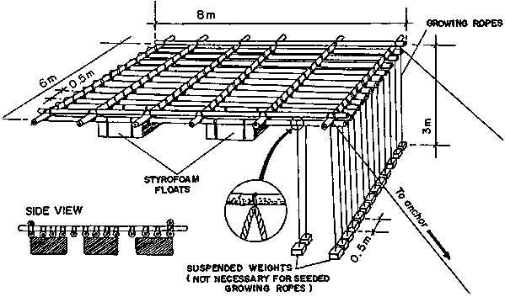
Fig. 23. Schematic diagram of a shellfish depuration plant (from SCSP, 1982c).
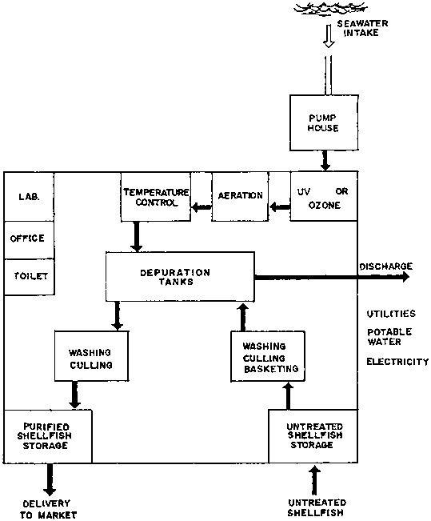
Table 13. Species under cultivation in the Asia-Pacific region
Seaweed Groups/Species | Country Where Cultivated
A. Green Seaweeds (Chlorophyta)
Caulerpa lentillifera J. Agardh | Philippines Japan
Enteromorpha sp.
Monostroma nitidum Wittrock | Japan
 | Taiwan, Pr. of China
B. Brown Seaweeds (Phaeophyta)
Ecklonia sp. | Japan
Eisenia sp. | Japan
Heterochoradaria sp. | Japan
Hizikia sp. | Japan
 | Korea, Republic of
Laminaria japonica Areschoug | Japan
L. japonica | China
 | Korea, Republic of
Macrocystis sp. | Japan
Nemacystus sp. | Japan
Nereocystis sp. | Japan
Sargassum sp. | Japan
Undaria pinnatifida (Harvey) Sur. | Japan
 | China
 | Korea, Republic of
U. Peterseniana (Kjellman) Okamura | Japan
U. undariodies (Yendo) Okamura | Japan
C. Bed Seaweeds (Rhodophyta)
Eucheuma alvarezii Doty | Philippines
E. denticulatum (Burman) Collins et Harvey | Philippines
E. gelatinae (Esper) J. Agardh | China
Gelidium amansii Lamouroux | Japan
Gloiopeltis sp. | Japan
Gracilaria verrucosa (Hudson) Papenfuss | Taiwan, Pr. of China
 | Japan
 | China
G. gigas Harvey | Taiwan, Pr. of China
G. lichenoides (L.) Harvey | Taiwan, Pr. of China
 | Japan
Porphyra angusta Ueda | Taiwan, Pr. of China
P. dentata Kjellman | Taiwan, Pr. of China
P. haitanensis Chang et Zhang Baofu | China
P. kuniedai Kurogi | Korea, Republic of
P. seriata Kjellman | Korea, Republic of
P. suborbiculata Kjellman | Korea, Republic of
P. tenera Kjellman | Japan
P. yezoensis Ueda | Japan
P. quangdongensis Tseng et T.J. Chang | Korea, Republic of China
Source: Trono, 1986
In Taiwan (PC), Gracilaria is cultured in ponds formerly used for milkfish, with Pingtung County alone accounting for 110 ha of the total 400 ha of Gracilaria ponds in Taiwan (PC) in 1974 and producing 1 000 t of dried Gracilaria seaweed.
In Japan, indoor facilities are used to obtain buds/seedlings for on-growing at sea. The facilities consist of 70-80 cm deep square or rectangular concrete tanks provided with illumination, a temperature control system, and ventilation (Mito and Fukuhara, 1988).
The successful cultivation of seaweeds depends on four important factors (Velasco, 1988):
(i) Type of Seaweeds Used
The seaweeds cultured must be healthy and resistant to disease and breakage. They must be able to grow fast and give high yields during harvest. During processing, they must have high amounts of dry matter from which will be extracted high concentrations of carrageenan of high gel strength and viscosity.
(ii) Ecological Conditions of the Farm
The farm must be well-sited and fulfill the bio-ecological requirements of the culture species. In general, the presence of a particular seaweed species in an area is a good indicator of the suitability of that site for culture of the species under consideration.
(iii) Access to Sunlight
Seaweeds being cultivated need abundant sunlight for photosynthesis. Shading by other seaweeds and plants must be prevented by regular inspection and removal of the unwanted plants.
(iv) The Seaweed Farmer
The personality and dedication of the seaweed farmer is an important factor since the farmer must visit the farm regularly and carry out routine inspections. Some of the farmer's chores include shaking off silt and other foreign materials from the seaweeds, repairing broken lines, restoring uprooted stakes, and picking up drifting branches of seaweeds.
Trono and Ganzon-Fortes (1988) listed the following criteria for selecting good sites for Eucheuma in open waters and Caulerpa and Gracilaria in seawater ponds:
(i) Unpolluted seawater supply.
(ii) Salinity of 30-35 ppt Eucheuma and Caulerpa and 8-25 ppt for Gracilaria.
(iii) Water temperature of 27-30* C.
(iv) Moderate water movement of 20-50 m/min.
(v) Water depth of 0.5-1 m at low tides and not more than 2-3 m at high tides, and
(vi) Firm bottom protected from strong waves for Eucheuma and muddy-loam bottom for Caulerpa ponds.
Seaweeds are grown using different types of planting material (vegetative cuttings, natural seeds, hatchery-reared seeds) and methods of culture (store planting, bottom culture, rope method, rope-concrete method, and pond culture either in monoculture or polyculture with milkfish, shrimp and crabs). These methods are described in detail by Trono (1986) and are summarized in Table 14.
Table 14. Types of planting material and methods of culture for different seaweeds
Seaweed Groups/Species | Country Where Cultivated | Type of Planting Material and Methods of Culture
A. Green Seaweeds (Chlorophyta)
Caulerpa lentilliferaJ. Agardh | Philippines | Vegetative propagation by cuttings; pond culture
Enteromorpha sp. | Japan | Naturally produced "seeds" grown on hibi nets in open seas
Monostroma nitidumWittrock | Japan Taiwan, Pr. of China | Hatchery-reared or naturally produced "seeds" grown on hibi nets in open seas
B. Brown Seaweeds (Phaeophyta)
Ecklonia sp. | Japan | Natural seeding on improved substrates
Eisenia sp. | Japan | Natural seeding on improved substrates or introduction of mother plants or seedlings
Heterochoradariasp. | Japan | No information available
Hizikia sp. | Japan Korea, Rep. of | Introduction of fertile plants on natural or artificial substrates; seeding of naturally produced spores or embryos on rocks
Laminaria japonicaAreschoug | Japan | Hatchery produced "seeds"; rope cultivation in open waters using artificial support system; natural recruitment on improved substrates; stone planting or bottom culture using artificially seeded stones
L. japonica | China | Hatchery produced "seeds"; rope cultivation in open waters using artificial support system; scone planting or bottom culture using artificially seeded stones
 | Korea, Rep. of | No information (probably same used In Japan)
Macrocystis sp. | Japan | Natural "seeds" on improved substrates; hatchery produced seedlings on twines introduced to artificial substrates
Nemacystus sp. | Japan | No detailed information available
Nereocystis sp. | Japan | No detailed information available
Sargassum sp. | Japan | Introduction of mother plants or seedlings; artificial substrates in open seas
Undaria pinnatifida(Harvey) Sur. | Japan China Korea, Rep. of | Hatchery produced "seeds"; raft or floating rope system in open seas; stone planting using artificially seeded stones; bottom planting in open seas; management of natural stocks by improvement of substrates for natural seeding
U. peterseniana(Kjellman) Okamura | Japan | Same as used for U. pinnatifida
U. undariodies(Yendo) Okamura | Japan | Same as used for U. pinnatifida
C. Red Seaweeds (Rhodphyta)
Eucheuma, alvareziiDoty | Philippines | Vegetative cuttings using artificial support system on open reefs
E. denticulatum (Burman) Collins et Harvey | Philippines | Same as used for E. alvarezii
E. gelatinae (Esper) J. Agardh | China | Vegetative cuttings tied to pieces of corals and planted on the bottom
Gelidium amansiiLamouroux | Japan | Natural seeding on improved substrates; vegetative cuttings scattered on the bottom and rope-concrete method
Gloiopeltis sp. | Japan | Artificial seeding of substrates using spore suspension or embryos
Gracilaria verrucosa(Hudson) Papenfuss | Taiwan, Pr. of China | Vegetative cuttings; pond monoculture and/or polyculture with milkfish, shrimp and crab
 | Japan | Vegetative cuttings Inserted in nets and ropes in protected bays and coves
 | China | Vegetative cuttings inserted in bamboo splits; net method; scattering cuttings on the substrate
G. gigas Harvey | Taiwan, Pr. of China | Same as used for G. verrucosa in Taiwan
G. lichenoides (L.) Harvey | Taiwan, Pr. of China | Same as used for G. verrucosa in Taiwan
 | Japan | Same as used for G. verrucosa in Japan
Porphyra angustaUeda | Taiwan, Pr. of China | Hatchery produced seeds; net-raft system in outgrowing areas
P. dentata Kjellman | Taiwan, Pr. of China | Hatchery produced seeds; net-raft system in outgrowing areas
P. haitanensis Chang et Zhang Baofu | China | Hatchery produced seeds on nets using the fixed, semi-floating or floating methods
P. kuniedai Kurogi | Korea, Rep. of | Same as used for P. tenera in Japan
P. seriata Kjellman | Korea, Rep. of | Same as used for P. tenera in Japan
P. suborbiculataKjellman | Korea, Rep. of | Same as used for P. tenera in Japan
P. tenera Kjellman | Japan | Hatchery produced seeds on bamboo blinds and (recently) on artificially fixed or floating support systems
P. yezoensis Ueda | Japan | Same as used for P. tenera in Japan
 | Korea, Rep. of | Same as used for P. tenera in Japan
 | China | Same as used for P. haitanensis
P. guangdongensisTseng et T. J. Chang | China | Same as used for P. haitanensis
Source: Trono, 1986
Fig. 24. Three methods of Eucheuma culture practised in the Philippines (from Alih, 1989). (MONOLINE METHOD)
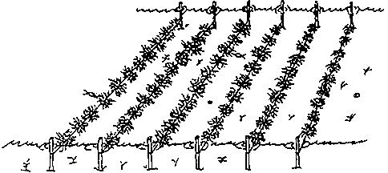
Fig. 24. Three methods of Eucheuma culture practised in the Philippines (from Alih, 1989). (NET METHOD)
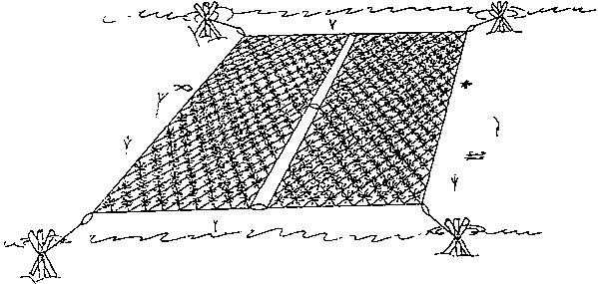
Fig. 24. Three methods of Eucheuma culture practised in the Philippines (from Alih, 1989). (FLOATING METHOD)
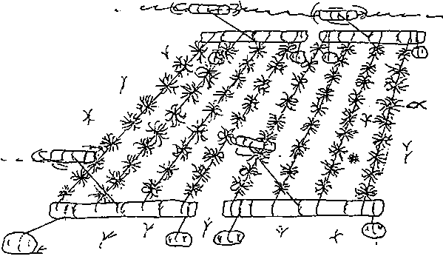
In the Philippines, the monoline method of culture is the most popular and successfully used of these methods (Fig. 24) (Alih, 1989). The farming activities involved in monoline culture of Eucheuma species based on the Philippine experience are as follows (Trono and Ganzon-Fortes, 1988):
(i) Securing a license from the Bureau of Fisheries and Aquatic Resources (BFAR) prior to farming the area.
(ii) Preparing required materials needed for farm construction.
(iii) Clearing the area of sea grass, seaweeds, large stones and corals, and other foreign materials, followed by measuring it according to the proposed dimensions of the farm.
Wooden stakes are then driven into the bottom with the help of an iron bar and sledgehammer and arranged into 10 m rows at 1 m intervals. An 11 m nylon line is securely tied to one end of each stake about 0.5 m above the ground and then stretched to the corresponding opposite stake and tied securely. If the current is very strong, an additional row of stakes is placed in the middle to provide additional support.
(iv) Obtaining seedlings from the nearest source and transporting them to the farm site within the shortest possible time. During transport, the seedlings are protected from exposure to sun, wind, heat or rain. If the transport of seaweeds will take several hours, the seaweeds are kept damp during the trip and upon arrival at the farm, are immediately submerged in water.
(v) Preparing the seedlings by tying bunches weighing about 50-100 g with soft 25 cm long plastic straw, and then tying these to monolines in the water at 20-25 cm intervals. The plants are allowed to grow to about 1 kg or larger before harvesting.
(vi) Building a farm house if drying of the harvested seaweeds is part of the operations. The farm house is built in or near the farm site so as not to waste time during post-harvest handling. The size of the farm house, which is designed to provide for drying and storage, will depend on the farmer's financial capacity and market commitments.
(vii) Maintaining planted seaweeds by inspecting them regularly while they are growing. Unwanted seaweeds which will compete with the Eucheuma for nutrients and sunlight are removed along with dirt and other foreign materials clinging to the seaweeds. Lost or broken Eucheuma are replaced.
(viii) Harvesting the whole plant and reserving select portions as seedlings for the next crop.
(ix) Sun-drying of the rest of the harvest by spreading these on a drying platform of bamboo slots initially lined with coarse fine-mesh nylon net. The seaweeds are freed of all foreign matter clinging to them.
During hot and sunny weather, it takes about 3-4 days to dry the seaweeds to a moisture content of about 30% or less. The dried materials are then packed in plastic sacks for storage in a dry place or for delivery to the buyer.
The pond culture of Caulerpa involves the following major steps (Trono, 1988):
(i) Pond Construction
The pond is divided into manageable units measuring about 0.10-0.25 ha. The pond design allows for a flow-through system by providing each unit with its own supply and drainage gates. Water flows uniformly from the main gate to the secondary and exit gates during the draining and flooding process. Peripheral diversion dikes or canals along the landward edge of the pond are also built to divert run-off water from the ponds during the rainy season.
(ii) Planting
To facilitate planting activities, pond water is drained to a depth of about 0.3 m.
Caulerpa seedlings are obtained from the nearest source available and transported to the farm site within the shortest possible time.
The ponds are stocked at a rate of 1 000 kg seedlings/ha or 100 g/m². A handful of seedlings is uniformly buried on one end at approximately 1 m intervals using a string as guide.
After planting, the pond water is gradually raised to a depth of 0.5-0.8 m or just until the plants can be seen from the surface of the water.
The newly planted seaweeds are inspected after a few days. Uprooted seaweeds are replaced and bare areas are replanted.
(iii) Pond Management
Water is changed daily or every other day to maintain adequate levels of nutrients. During the initial stages of growth, the seaweeds deplete the water of nutrients at a high rate and frequent water changes are needed to replenish lost nutrients and eliminate the need to fertilize. Water level is, however, carefully maintained to prevent the collapse of the dikes.
Unwanted seaweeds, sea grasses, and animals which will compete with the Caulerpa for nutrients are regularly weeded out.
The dikes and pond gates are inspected regularly to check for leakages, which are repaired immediately. This is vital, especially during the typhoon season.
The application of fertilizer may not be necessary as long as frequent water change is maintained. However, fertilization is resorted to when the stocks appear unhealthy and pale in colour, i.e., from light green to yellowish. When this happens, pond water is changed and fertilizer with a high nitrogen content is applied at the rate of 16 kg/ha by broadcasting or by suspending the fertilizer contained in several layers of plastic sack in strategic areas in the pond. The pond water is not changed in the next two to three days.
(iv) Harvesting
Two months after planting, the Caulerpa forms a uniform carpet on the pond bottom, a good indicator for harvest time.
About 75% of the crop is harvested by uprooting the Caulerpa from the mud and placing it on to a wooden raft.
About 25% of the original crop is left behind, uniformly spaced on the pond bottom to serve as seedstock for the next crop. This may be harvested after two to three weeks.
Harvested seaweeds are washed in clean sea water to remove mud and other dirt. The clean seaweeds are then placed in a basket or clean plastic sheets for further sorting and cleaning before packaging and immediate transport to the market.
http://www.fao.org/docrep/T8598E/t8598e05.htm#4.2 overview of aquaculture methods and practices

